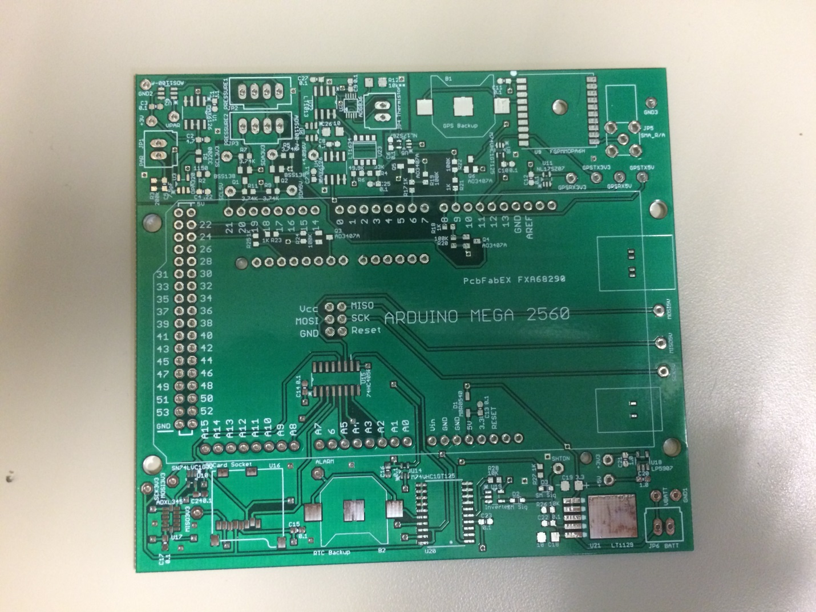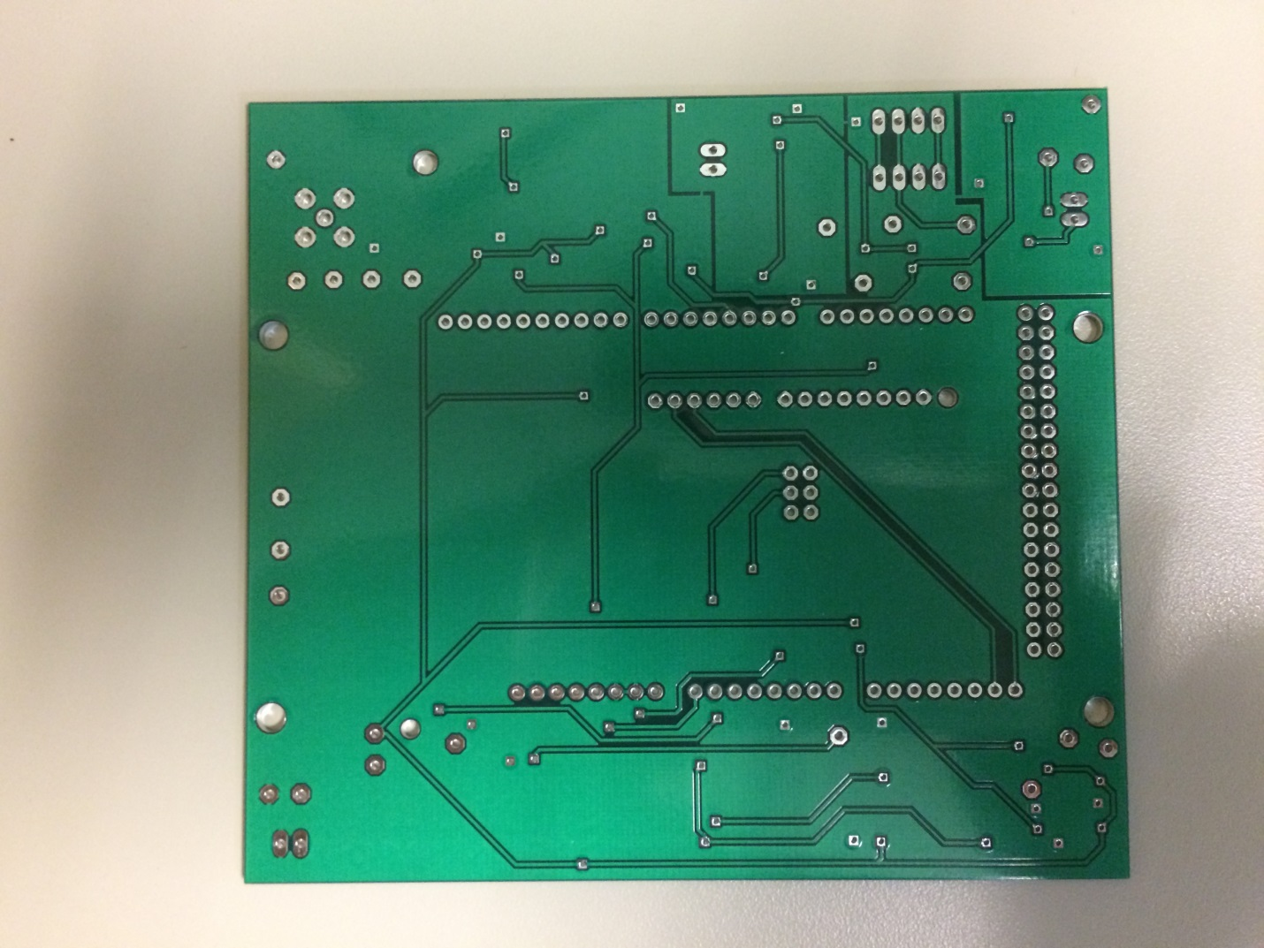

2x3 Female Header

Female Headers

Male Headers

Male Headers

Male Headers